**Generate Payslip – User Manual**

Step 1: click “Payslip” button from the menu as shown below.

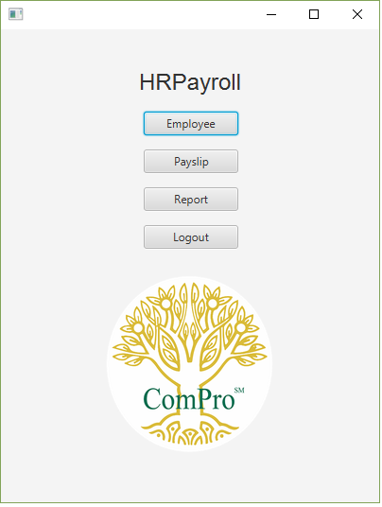

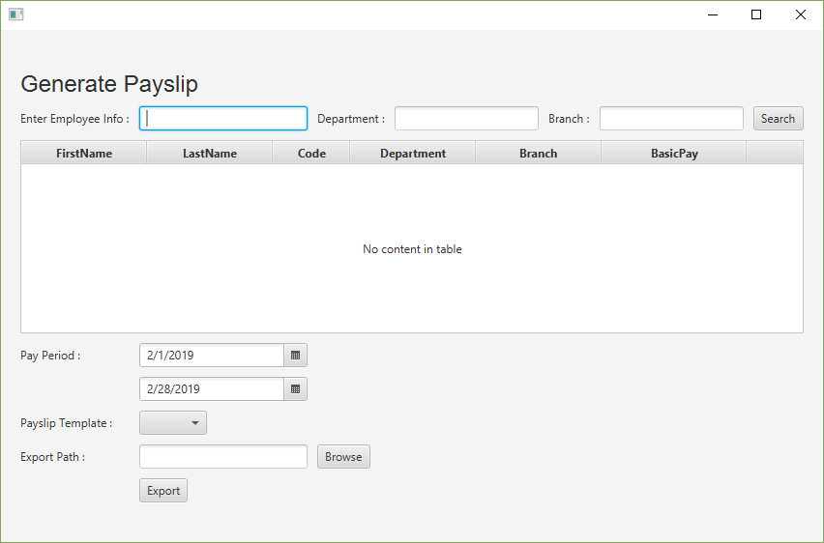Generate Payslip page will show as below:

Step 2: Enter “Department”, “Branch”, “Employee Code” or “Employee Name” to search an employee.



Step3: Click search button to search and employee.



Step 4: Select Pay Period and Payslip Template.

Step 5: Browse folder path to store the generated file.



Step 6: Click “Export” button to begin exporting the Payslip files.



Step7: Below alert will display after successful file exporting.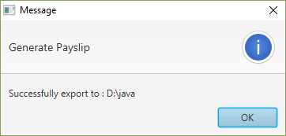

Below are the files exported in selected location.

